Nama:Sultan Mu’ammal Khair

Nim:2400018131

Slot: Alpro Selasa 10.00-13.45(lab basis data)

LAPRAK

Program:

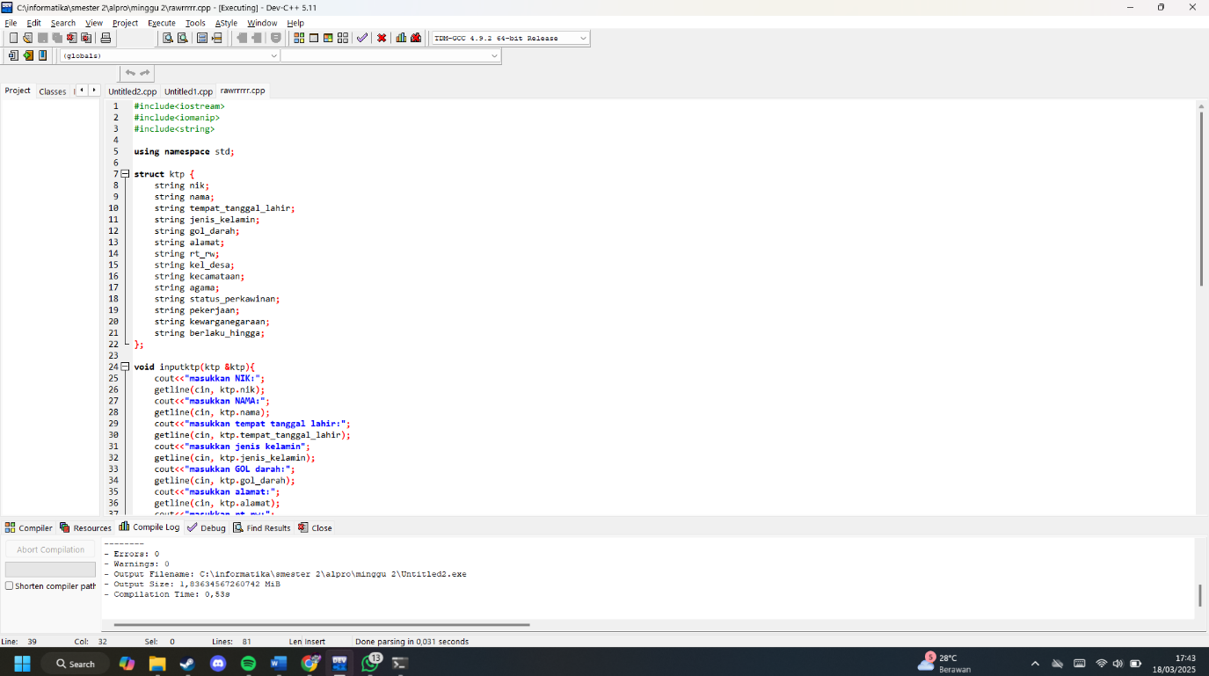

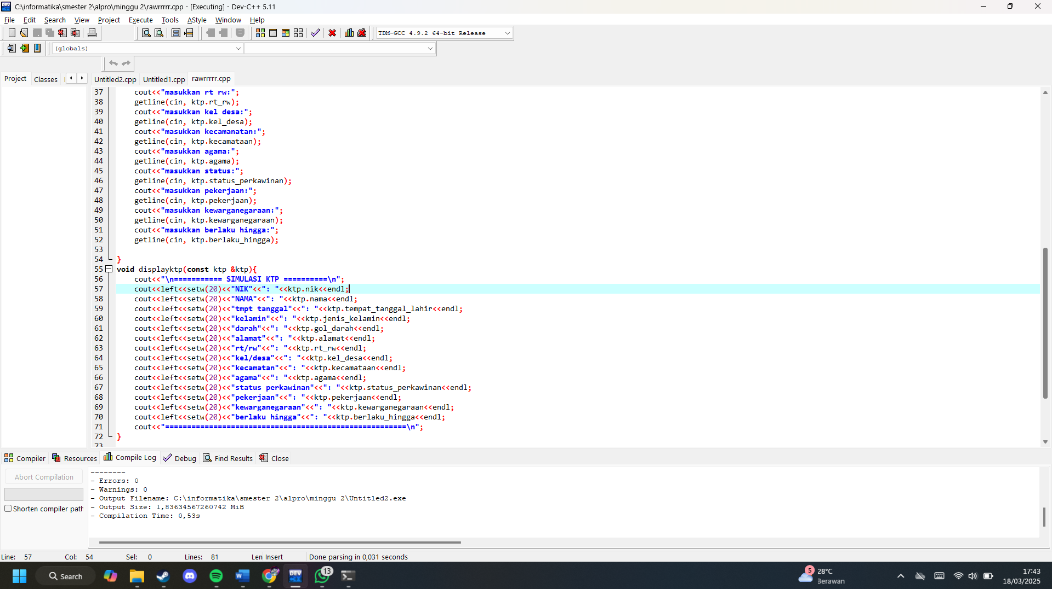

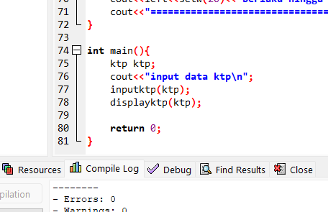

OUTPUT PROGRAM:

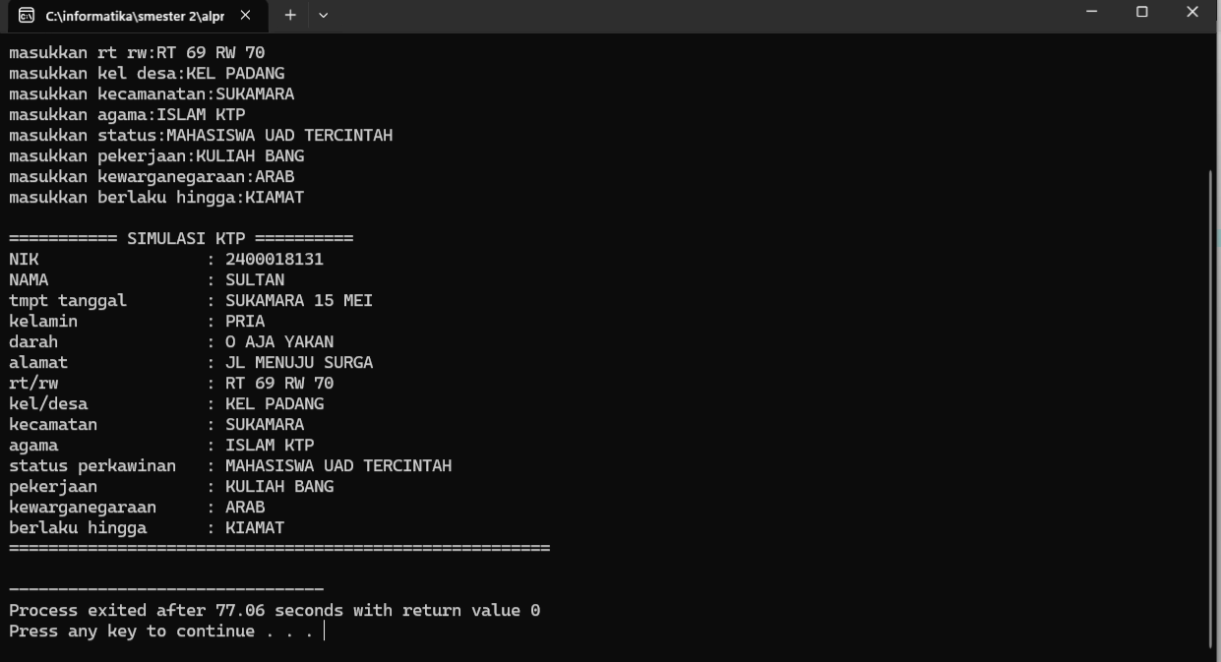

POST TEST

Program:

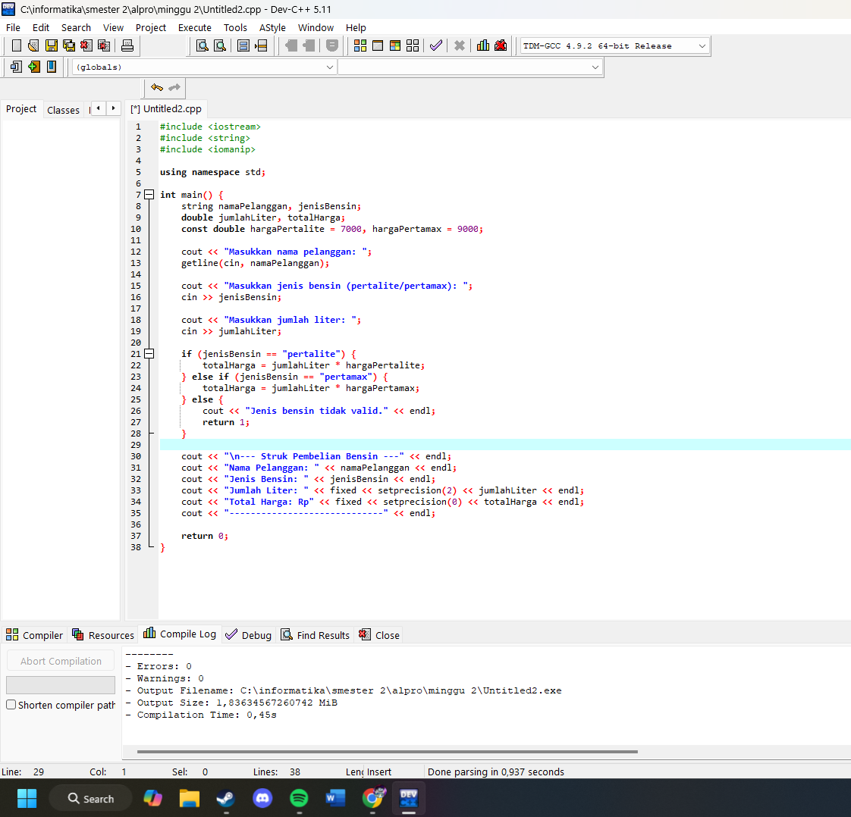

OUTPUTPROGRAM:

